Ann Farrell  CPCC, PCC  Master Executive | Successful Executive – Executive, Leader Coach  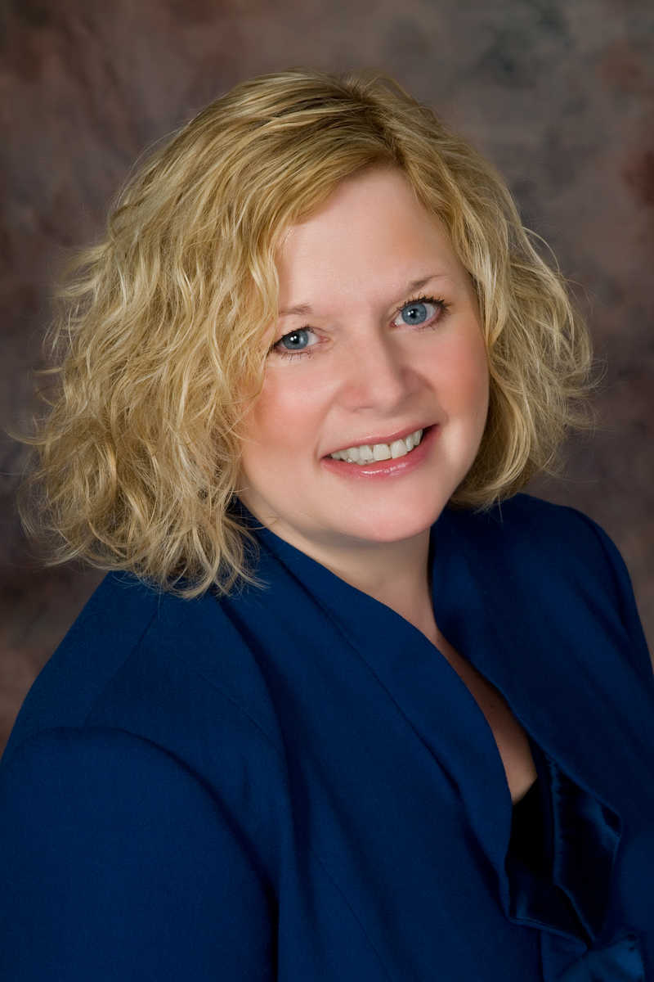  Igniting high performance through  “InPowered” Leadership  Quantum Endeavors®, Inc.  Founder and President (2006 – Present)  I am an executive, business and leadership coach who ignites high performance in people and organizations through “InPowered” Leadership. My passion for empowering people to fully step into their personal and professional best is at the heart of my coaching. “Only when we step out of the “role” and into the “real” can we reach our full potential.” As the only woman to rise from entry level to the top of the house in the 150-year history of my Fortune 200 company, I combined my 30-years of corporate experience testing what works best with coaching best practices to create my trademarked programs and tools that consistently deliver great results for my clients and my client companies which now include Fortune 500 companies including GE, the Chicago Cubs Organization, wildly successful small businesses and top performing individuals.  My signature leadership development coaching system for executives, leaders and teams has been selected by more than 50 corporate coaching firms now licensed and using it for all of their coaching engagements. Additional programs include “Your Corporate Success”, a group coaching experience, Quantum EQ, (Emotional Intelligence), Quantum Game Changers (Innovation), Quantum Start™ (Successful On-boarding), SOAR to Success (6 month virtual “next level” leadership program), “You InPowered™”, “Leader InPowered™”, “Women InPowered™”, and Quantum Team are all part of the Quantum Endeavors® “InPowered ” Leadership program offering.  Career Achievements  Navistar International corporation (June, 1976 – June, 2006)  - Chief Procurement Officer, VP, Purchasing and Logistics - Led an $8 billion purchasing organization to breakthrough levels of profit contribution  - VP, Product Development - Led cross-functional product development driving a billion dollar program from concept to market, 2800 people  - VP, Human Resources and Leadership Development – President-in -training Led leadership development and cultural change, more than 5000 people  - A 30-year career of exceptional performance and impact in positions including finance, treasury, strategy, transportation, purchasing and human resources  - Board Member, Women of the World organization (currently)  - Board Member, Benedictine University Masters in Leadership (currently)  - Executive Company Chair, United Way Organization (3 years)  I have been a mentor, coach and “real” model to many throughout my career. I am a highly credentialed Master Executive Coach, Certified Professional Co-Active Coach (9/7/06) and credentialed by the International Coach Federation as a Professional Certified Coach since 10/2/07, one of less than 1,500 coaches worldwide to earn that distinction.  Client companies include: The Chicago Cubs Organization, General Electric (GE), Navistar International, Allstate Insurance Company, British Petroleum (BP), Alcoa Corporation, CDW, DeVry, Chamberlain College of Nursing, National Speakers Bureau, Players Choice, Sara Lee Corporation and more as well as more than 100 wildly successful business owners and individual professionals.
Corporate Success
Coach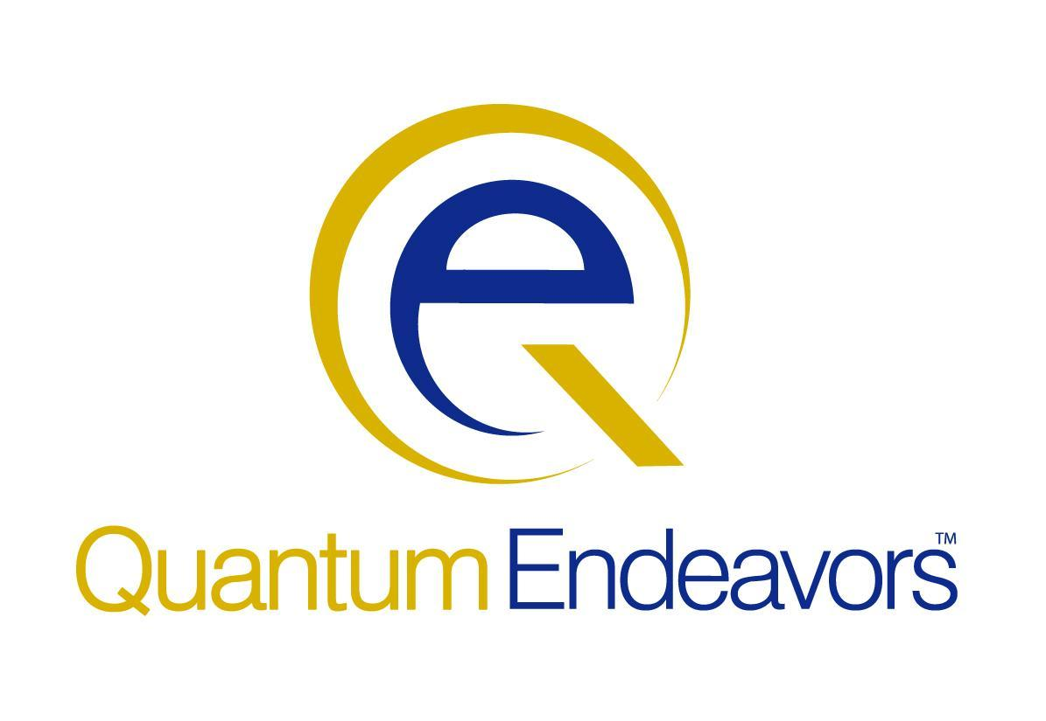
www.quantumendeavors.com

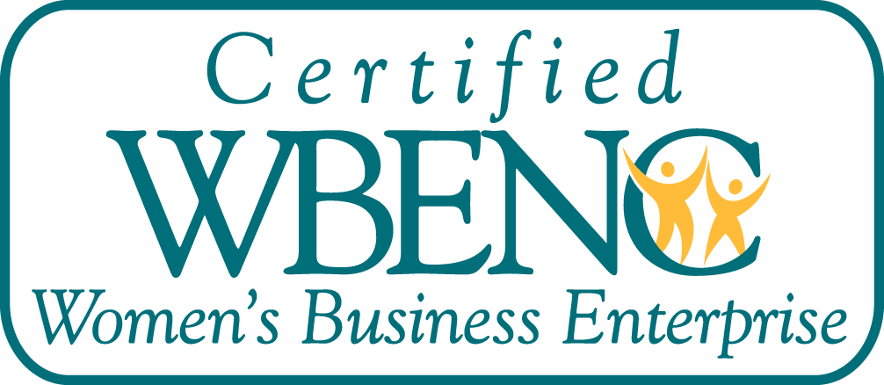

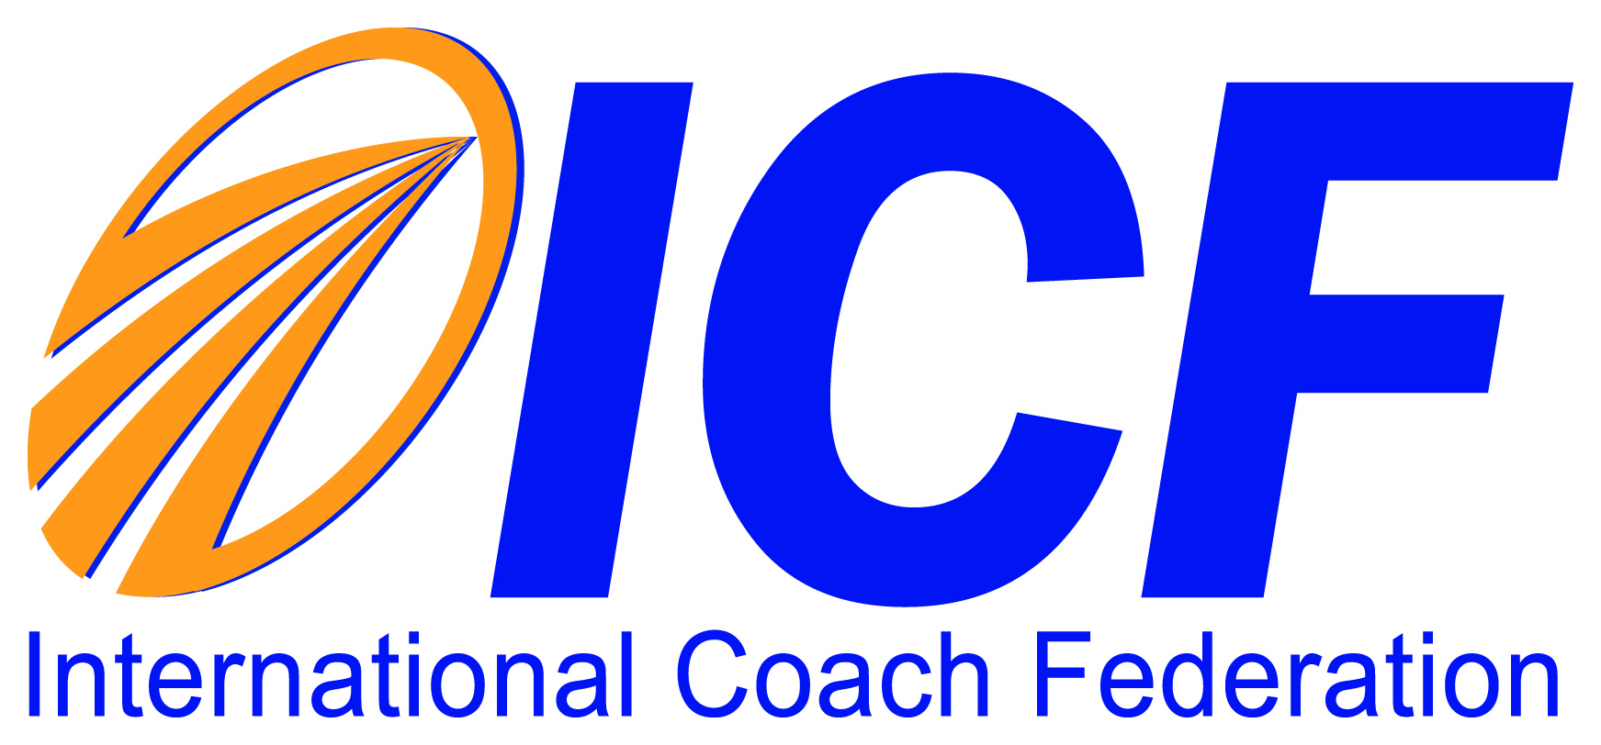

"Coaching with Ann has been the best experience of my life, truly life changing."
Patti B.
Schaumburg, IL

"I am a better CEO, husband, father and son because of my coaching with Ann. She showed me how to bring my best to everything that is important to me."
John D.
Chicago, IL

"People who are fortunate enough to have Ann Farrell as their coach will experience a powerful revelation about their own strengths, possibilities and opportunities." Kally R.
Palatine, IL

"Ann's coaching was instrumental in my new big promotion! I am forever grateful for her wisdom, her insights and most of all, her not letting me off the hook!"
Steve P.
Detroit, MI

1s721 Alsace Court
Winfield, Illinois 60190
630.743.1552
ann@quantumendeavors.com

